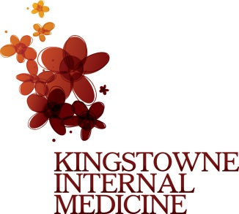

***Disclaimer: All Kingstowne Internal Medicine patients receive email updates. Email updates may include but not limited to information about closings, inclement weather schedules, holiday schedules, new services and new providers. If the email update does not concern or interest you we kindly ask you to delete the message. If you are no longer a Kingstowne Internal Medicine patient please reply back so we may remove you from our email list.***
Signature:_______________________
Date:_____________________________

